ENGLISH

**Koh Hau-Tek**

Singapore

Deputy Chief Medical Officer of Jiahui Health

1. Deputy Chief Medical Officer co-overseeing clinical services and actively involved in clinical operations and product development at Jiahui Health;
2. Chair of the Jiahui vaccination and clinical products committees;
3. Sits on various committees including privileging & credentialing, clinical standards, medical executive council, medical policies, peer review;
4. Managed another medical group prior to Jiahui, responsible for all operations of the group’s healthcare assets, across 6 cities in China;
5. Practicing physician for over 20 years in other major medical groups in Singapore and the Republic of Ireland;
6. Have sat on and presided over Medical Boards and Clinical Governance committees in several medical groups, including public-listed Parkway Health (IHH) and Healthway Medical Group in Singapore;
7. Vice-President, International Business Development, with focus on strategy and business development at Certis CISCO Pte Ltd, driving merger and acquisition activities;
8. 1st class Honors medical degree & an intercalated Bachelor of Medical Science at National University of Ireland;
9. Membership to the Royal College of Surgeons in Ireland;
10. Master in Medicine (Surgery), Singapore;
11. Registered Family Physician with the Singapore Medical Council and a registered Designated Workplace Doctor with Singapore’s Ministry of Manpower;
12. Completed an Advanced Management Program at Nanyang-UC Berkeley;
13. Master Degree of Business Administration (MBA) from Nanyang Business School in Nanyang Technological University Singapore;
14. Adjunct lecturer in Occupational Medicine at the National University of Singapore

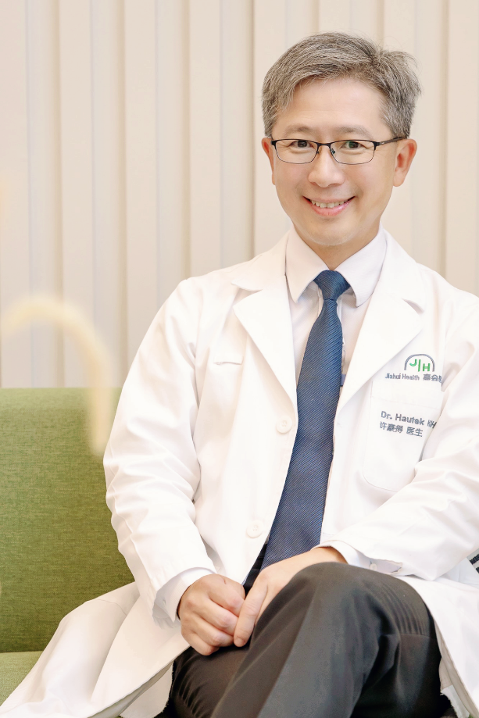

Dr. Koh has been working closely with TEC as a partner in having COVID-19 vaccinations for expats and TEC members. In this time of COVID in China, Jiahui International Hospital continues to provide a critical support pillar by having COVID-19 vaccinations in a credible world-class facility with strong operational capabilities, and a good track record and well-trained medical/nursing staff.

In addition, Jiahui International Hospital and Jiahui Clinics have been open throughout the Shanghai lockdown recently, continuing to provide much needed healthcare services in the clinics, outpatients, emergency department, inpatients, and surgeries in multiple medical departments.

Dr. Koh continues to support TEC through provision of cost-effective world-class healthcare and its related clinical capabilities.

中文

**Koh Hau-Tek 许豪得**

新加坡

嘉会医疗-嘉会国际医院副首席医务官

1. 嘉会医疗-嘉会国际医院副首席医务官，共同监督临床服务，积极参与嘉会健康的临床运营和产品开发；
2. 嘉会疫苗和临床产品委员会主席；
3. 担任各种委员会成员，包括特权和资格认证、临床标准、医疗执行委员会、医疗政策和同行评审；
4. 在来到嘉会前，管理了另一个医疗集团，负责集团医疗在中国6个城市资产的所有运营；
5. 在新加坡和爱尔兰的主要医疗集团担任执业医生超过20年；
6. 曾担任和主持多个医疗集团的医学委员会和临床治理委员会，包括上市的Parkway Health (IHH)和新加坡Healthway Medical Group；
7. 国际业务发展副总裁，专注于Certis CISCO Pte Ltd. 的战略和业务发展，推动及并购活动；
8. 爱尔兰国立大学一级荣誉医学学位和医学科学插班学士学位；
9. 爱尔兰皇家外科医学院会员；
10. 医学硕士(外科学)，新加坡；
11. 新加坡医疗委员会的注册家庭医生和新加坡人力资源部的注册指定工作场所医生；
12. 在加州大学伯克利分校完成高级管理课程；
13. 新加坡南洋理工大学-南洋商学院-工商管理硕士学位；
14. 新加坡国立大学职业医学兼职讲师。



许医生与TEC密切合作，为外籍人士和TEC群体提供接种新冠疫苗的帮助。在中国新冠疫情的这段时间，嘉会医疗：嘉会国际医院持续提供关键的支持。该院有着可靠、世界一流的设施和强大的运营能力、良好的记录和训练有素的医疗/护理人员的支持下提供疫苗接种服务。

此外，在上海封控期间，嘉会国际医院和嘉会诊持续开放，继续在多个医疗部门的诊所、门诊、急诊、住院和外科提供急需的医疗服务。

许医生继续通过提供具有成本效益的世界级医疗保健及其相关临床能力来支持TEC。

